Chapter 8, Solution 11.

s² + 2s + 1 = 0, thus s_{1,2} = 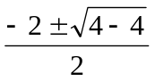 = –1, repeated roots.

v(t) = [(A + Bt)e^{-t}], v(0) = 10 = A

dv/dt = [Be^{-t}] + [-(A + Bt)e^{-t}]

dv(0)/dt = 0 = B – A = B – 10 or B = 10.

Therefore, v(t) = [(10 + 10t)e^{-t}] V

